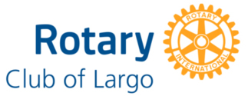
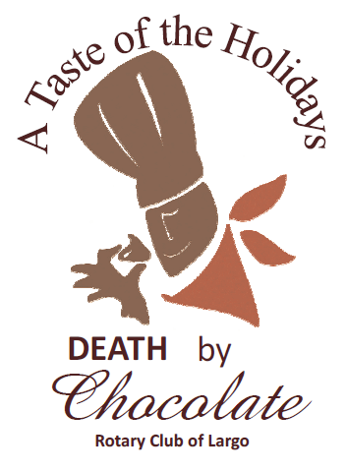
2024 Death by Chocolate Recipient Request Form
Thank you for your interest! Our club’s focus is youth initiatives in the greater Largo area.

- Name of organization
_________________________________________________________________________________________________________
- Address of organization __________________________________________________________________________________________________________________________________________________________________________________________________________________

- Contact person name, email and/or phone number
__________________________________________________________________________________________________________________________________________________________________________________________________________________
Attach this cover page with an additional 1-2 pages that describe what service this organization provides. Please feel free to attach a brochure. In your written description, be sure to include:
Largo Impact: Describe the need of the project/organization in the community. How does the project/ organization serve the Largo area?
Youth Impact: As the Rotary Club of Largo is very youth-focused in its funding priorities, how does the project/ organization benefit youth initiatives?
Recognition & Impact: In what ways will the project/ organization recognize the Rotary Club of Largo’s contribution? In what way will the project/organization be impacted by the Club’s funding?

Is the project aligned with one of the 7 Rotary Areas of Focus?
  - Peacebuilding & Conflict Prevention e. Basic Education & Literacy
  - Disease Prevention & Treatment f. Community Economic Development
  - Water, Sanitation & Hygiene g. Environment
  - Maternal & Child Health

  - Basic Education & Literacy
  - Community Economic Development
  - Environment

- Has program/organization been the recipient of Death by Chocolate funds in the past?

- Has project/organization contributed or supported Death By Chocolate event in the past through ticket sales, silent auction donation, volunteering or obtaining sponsors?

- If chosen, in what way will the organization be willing to support our annual Death by Chocolate event this upcoming year and in the future? select all that apply:

_____Donate a silent auction basket or item _____Help Volunteer _____Sell tickets _____Obtain Sponsor

Amount requested (up to $2,500): $________________
Rotarian Affiliated with Your Request: ___________________________________________________________________
All applications are due by Friday, February 21, 2025

Application can be submitted to a Rotarian, mailed to PO Box 578 Largo, Fl 33779 or emailed to largo.rotary@gmail.com

